**Practical1.** **Write SQL query to show default databases, create database and use it and create tables and insert value in the tables**.

***Query1. Write SQL Query to show default databases in MySQL.***

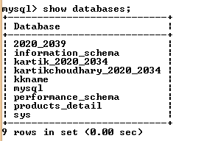

***Query2 .Write SQl query to Create database Sales.***



***Query3 .Write SQl query to Show database Sales.***

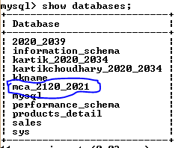

***Query 4. Write SQL query to use database.***



..

***Sales_2120 Table***

***Query 5.Write SQL query to Create Sales_2120 Table.***

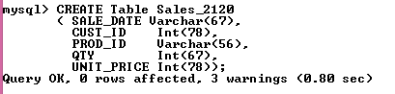

***Query 6. Write SQL query to Describe Sales_2120 Table.***

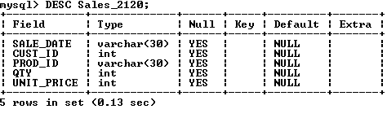

***Query7. Write SQL query to insert single record and retrieve the record from Sales_2120 table.***



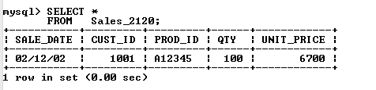

***Query 8. Write SQL query to insert values to Sales_2120 Table***

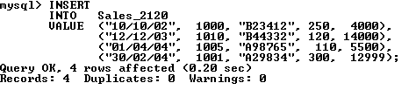

***Product_2120 Table***

***Query 9. Write SQL query to create a Product_2120 Table.***

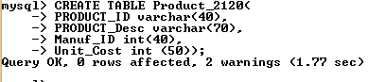

***Query 10. Write a SQL query to describe the structure of the Table.***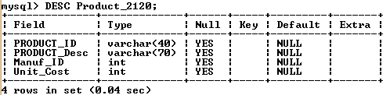

***Query 11. Write SQL query to insert and retrieve a single record in the Product_2120 Table.***



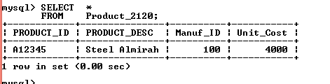

***Query 12. Write SQL Query to Insert Multiple Records in single Insert statement in Product_2120 Table.***

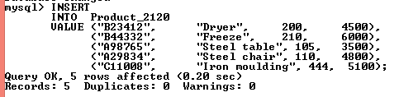

***Customer_2120 Table***

***Query 13. Write SQL query to CREATE The Customer_2120 Table.***

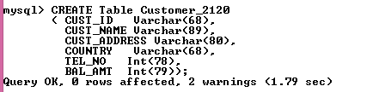

***Query 14. Write a SQL query to describe the structure of the Customer_2120 Table.***

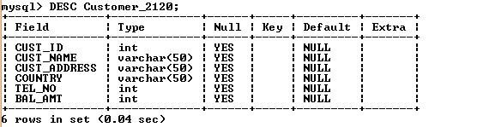

***Query 15. Write a SQL query to insert a single record in the customer_2120 Table.***



***Query 16. Write a SQL query to insert multiple records in the Customer_2120 Table.***

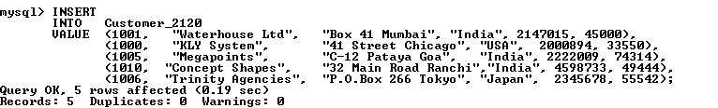

***Employee_2120 Table***

***Query 17.Write a SQL Query to create employee_2120.***

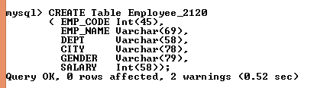

***Query 18. Write a SQL Query to describe the employee_2120 Table.***

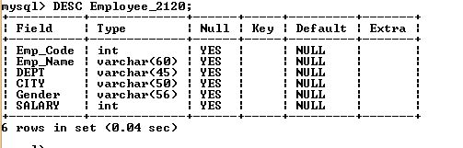

***Query 19.Write a SQL Query to insert single record in employee_2120 table.***



.

***Query 20. Write a SQL Query to insert multiple records in employee_2120 table.***

